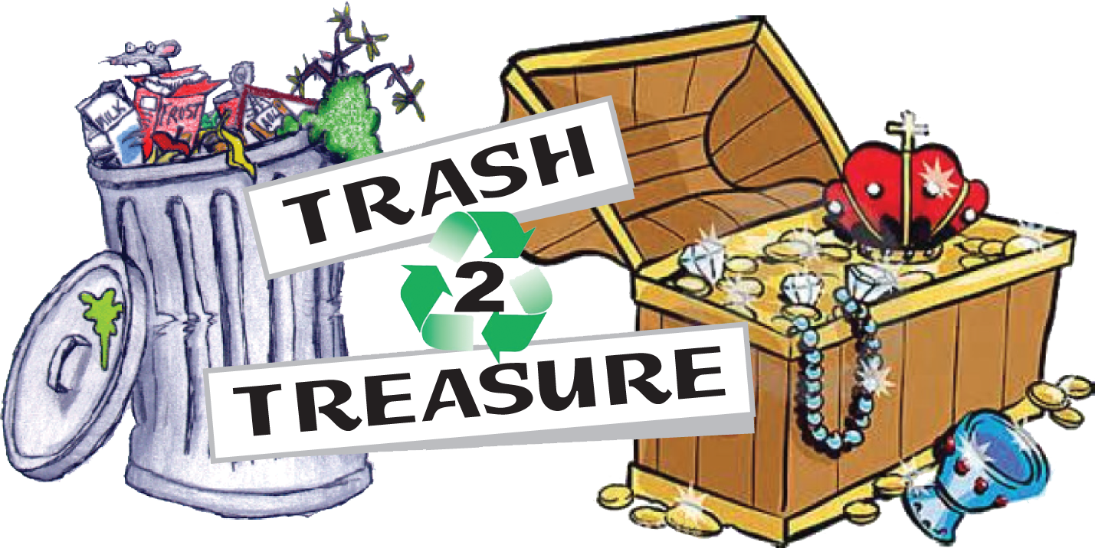
Mail completed form with check
or money order payable to:
Town of Niagara

Trash to Treasure
Paige Printup
7000 Lockport Road
Niagara Falls, NY 14305

Name:________________________________________________________________________________________

Business Name: (If applicable)____________________________________________________________

Address:______________________________________________________________________________________

Telephone: (Cell)_____________________________________________________________________________

E-mail:________________________________________________________________________________________

Brief description of product(s):_____________________________________________________________

_________________________________________________________________________________________________

Additional requests. (Reasonable requests will be addressed prior to the day of event)

_________________________________________________________________________________________________

☐ Town Resident (Driver’s License required. Please attach a photocopy.)

10 x 10 space $25.00 X _____ = $______________ 10 X 20 space $50.00 X _____ = $_______________

Total Enclosed $ __________________
NO REFUNDS AND NO RAIN DATE
☐ I have included a check for the above items for the 2024 Town of Niagara Trash to Treasure and I have read and understand the terms and conditions of the event.

Signature:______________________________________________________Date: _______/___________/_________________
APPLICATION/PAYMENT DEADLINE – June 3rd, 2023
Contact Information: Paige Printup • pprintup@townofniagara.com

