TRASH TO TREASURE
Craft Show & Garage Sale
Saturday, June 15th, 2024
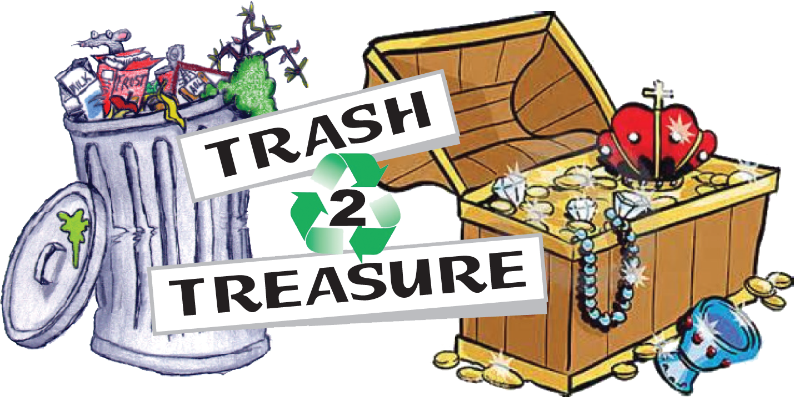
9:00am – 2:00pm
Location: Veteran’s Memorial Community Park
7000 Joe Rotella Way, Niagara Falls, NY

The Town of Niagara is pleased to present Trash to Treasure Craft Show and Garage Sale. This is a free event to all Town of Niagara residents. There is a small fee for non-residents and crafters, however ALL THOSE INTERESTED MUST APPLY TO RESERVE YOUR SPOT.

Terms and Conditions
- Spots are rented on a first come, first serve basis.

- Attendees will be permitted to have one car drive up to their spot and be permitted to stay there for the duration of the event.

- Town of Niagara may choose to deny any vendor based on appropriateness of products and duplication of vendors.

- Vendors may not sell any type of products that are deemed to be anti-American.

- Set-up begins at 7:00am and all vendors must be set up by 8:30am.

- Electrical access is very limited and will be provided on a first come, first serve basis. Vendors will be required to bring their own extension cords.

- Participants are responsible to bring their own, tents, tables, chairs, etc.

- Participants are responsible for the set-up/cleanup of their own tables.

- Participants cannot impair other tables (i.e. sign or display blockage)

- There are no other fees, participants keep all profits from their respective sales.

- Event will run rain or shine

- Cancellation Policy: ALL FEES ARE NON-REFUNDABLE
For further information please contact the Recreation Department at 716-297-5243 Ext1

